Screenshots for CustomerView

Database bamazon

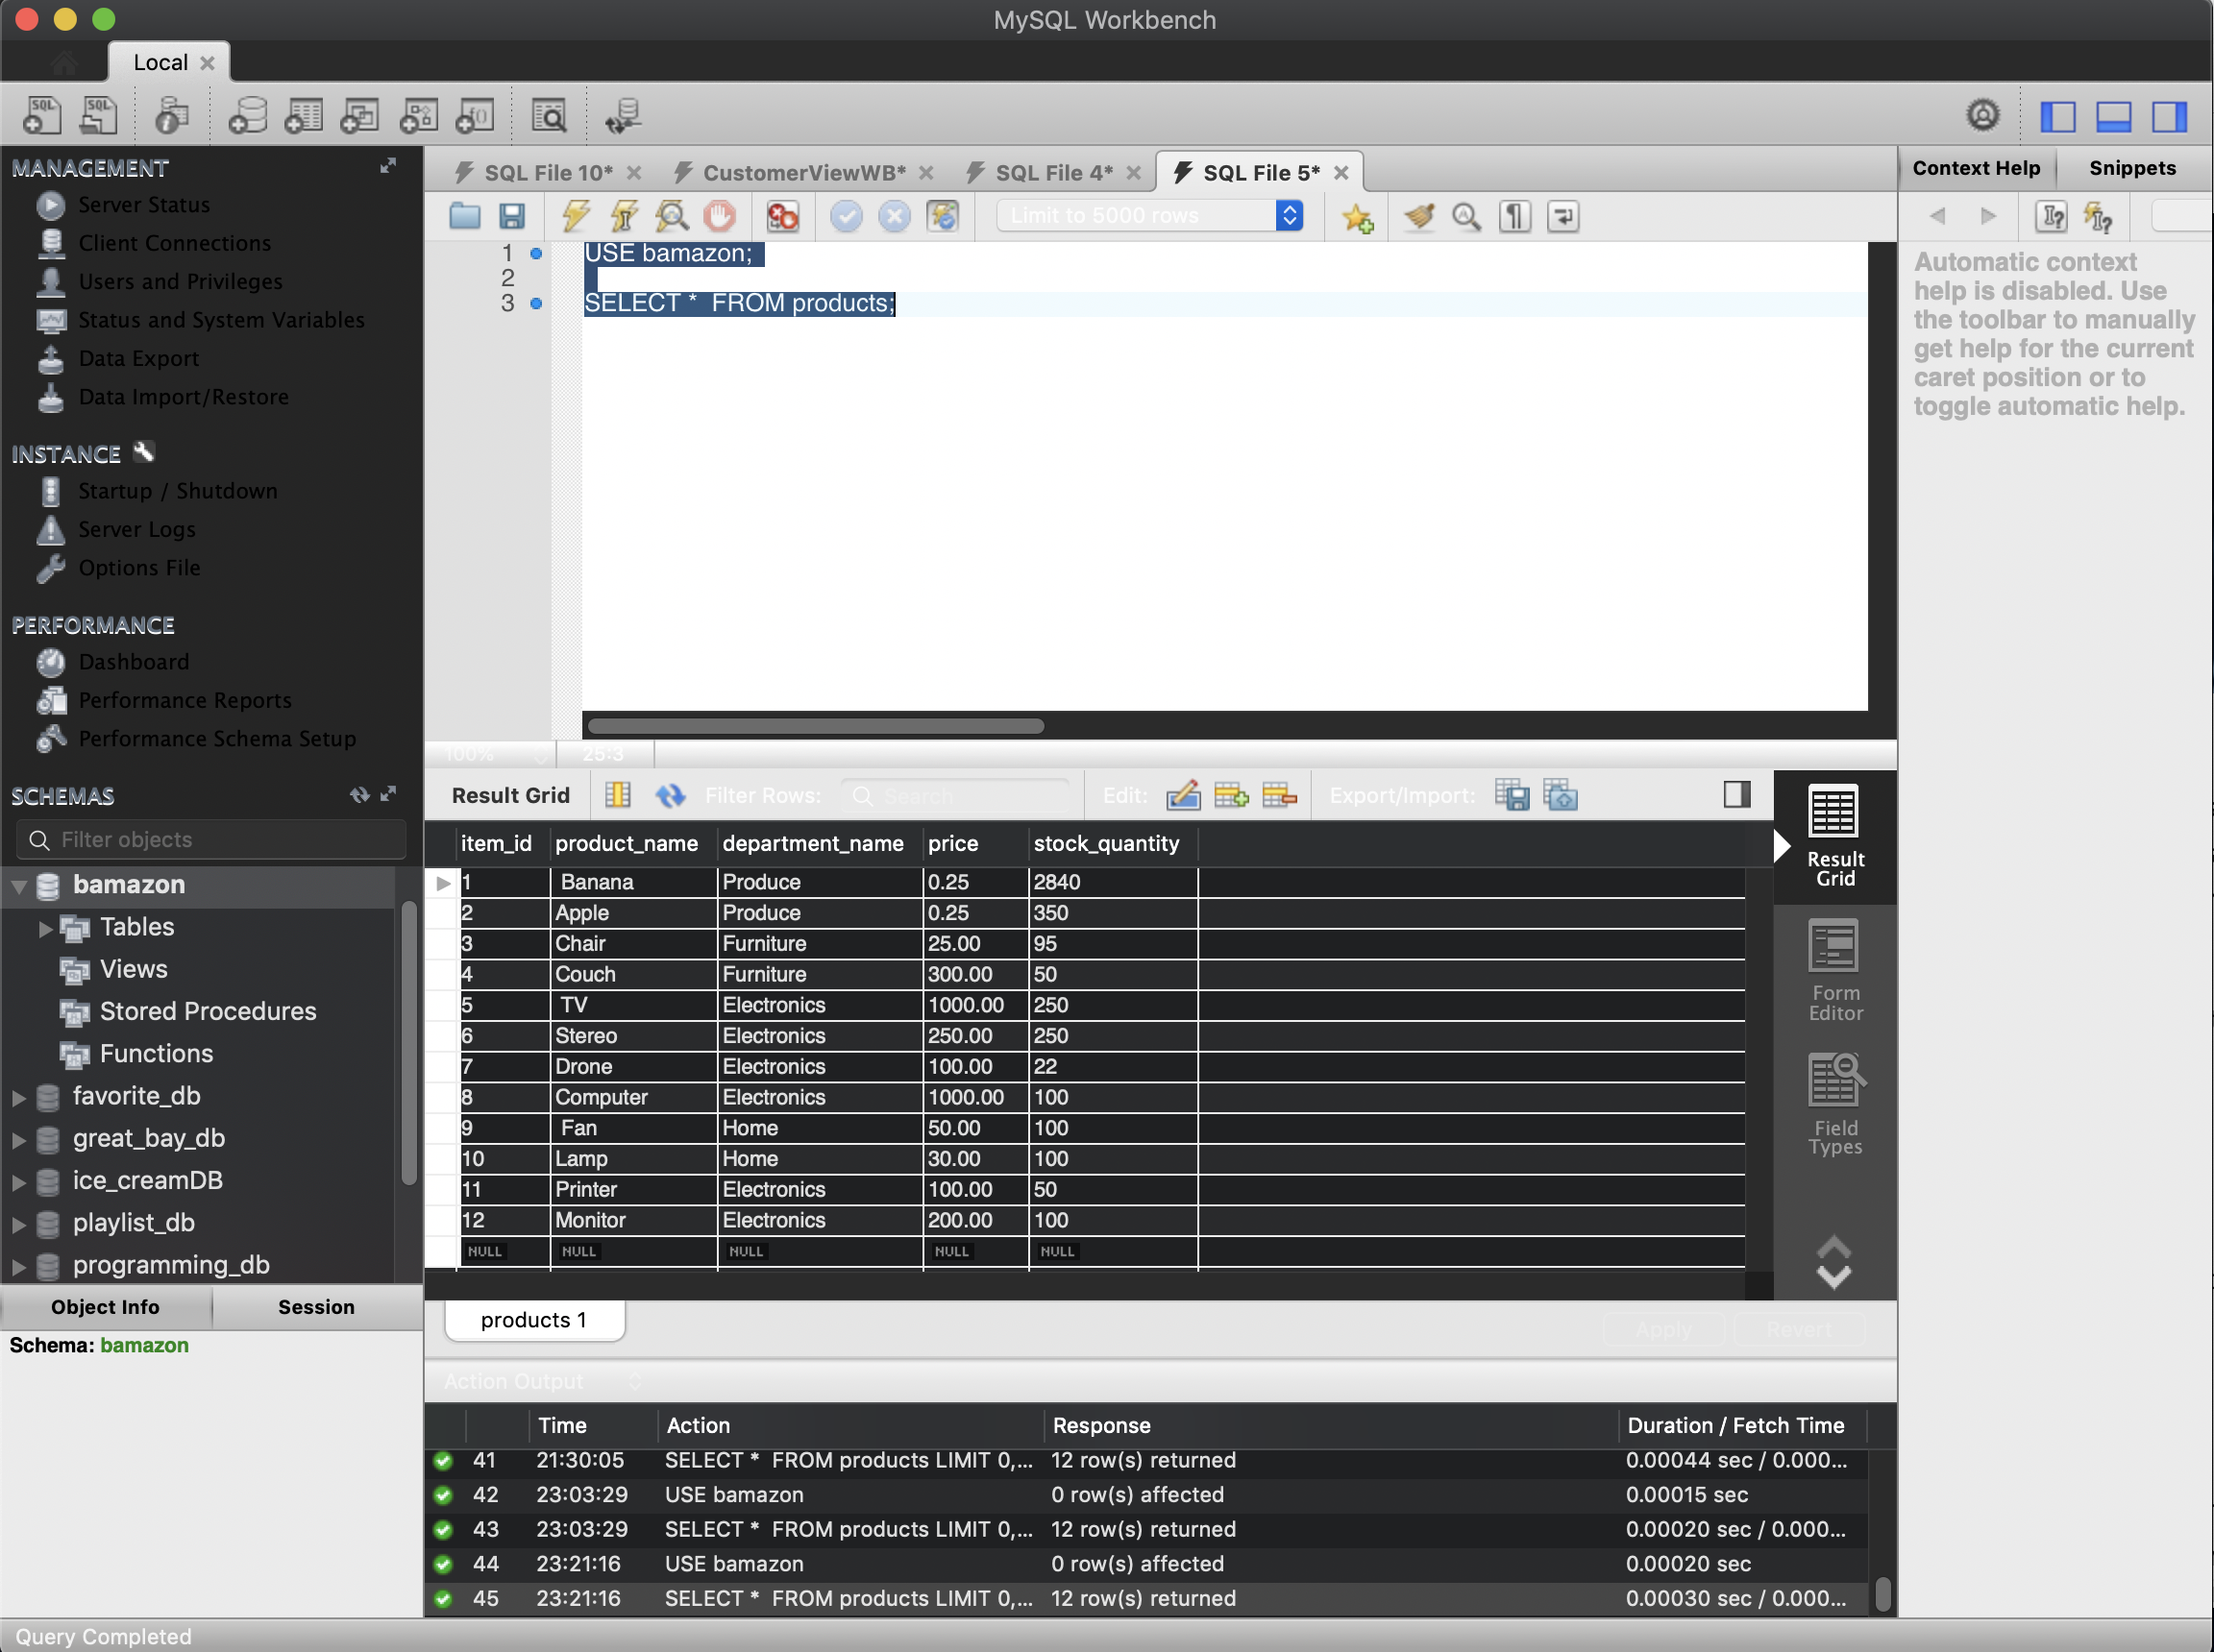

Initial run for CustomerView (bamazonCustomer.js)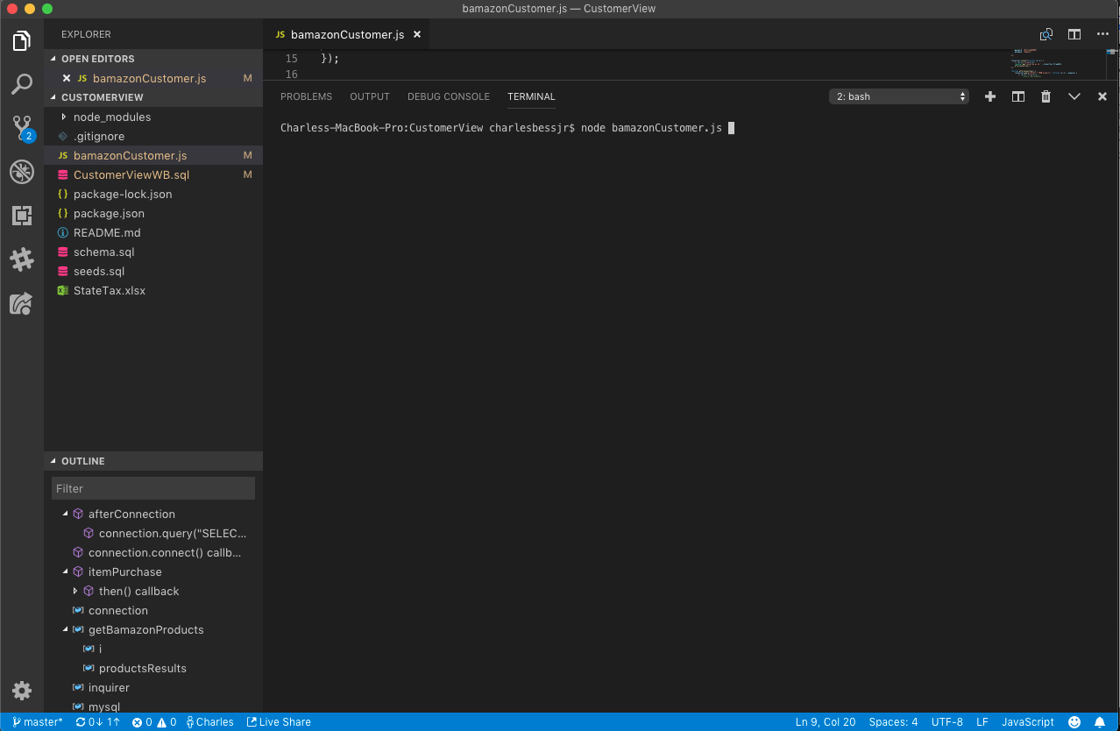

Response for the database table Products

Request for purchase of item_id:3 and a quantity: 5



Request for purchase of item_id:15 and a quantity: 50. Denied because the item_id does not exist



Request for purchase of item_id:6 and a quantity of 60000. Denied because the stock does not meet the request



Screen capture of the database prior to request for item_6. Current stock is 250

Request for purchase of item_id:6 and a quantity:50. Completed successfully



Screen capture of the database after the request for item_6. Current stock is now 200

